[Agricultural Water Management 255 (2021) 107047](https://doi.org/10.1016/j.agwat.2021.107047)

Contents lists available at [ScienceDirect](http://www.sciencedirect.com/science/journal/03783774)

Agricultural Water Management

journal homepage: [www.elsevier.com/locate/agwat](https://www.elsevier.com/locate/agwat)

Characterizing potato yield responses to water supply in Atlantic Canada’s [](http://crossmark.crossref.org/dialog/?doi=10.1016/j.agwat.2021.107047&domain=pdf) humid climate using historical yield and weather data: Implications for supplemental irrigation

Yefang Jiang a,*, Matt Ramsay b, Fanrui Meng c, Tobin Stetson d

a *Charlottetown Research and Development Centre, Agriculture and Agri-Food, Canada*

b *Kensington North Watersheds Association, Prince Edward Island, Canada*

c *Department of Forestry and Environment Management, University of New Brunswick, Canada*

d *Prince Edward Island Department of Agriculture and Land, Canada*

A R T I C L E I N F O

Handling Editor - Dr Z. Xiying

*Keywords:*

Groundwater allocation Climate change Evapotranspiration Cost-benefit analysis Aquatic ecosystems

A B S T R A C T

Knowledge about potato yield responses to water supply at low, optimum and high levels is required to inform supplemental irrigation (SI), but short-term irrigation experiments may not produce this knowledge in a humid environment because of the difficulty in accurately controlling water supply with uncertain precipitation. This study was conducted to characterize potato yield responses to water supply by treating the 2001–2018 potato yields in Prince Edward Island (PEI), Canada as the results of an un-replicated irrigation experiment with growing season (GS) precipitation as irrigation water supply and utilize the results to inform SI. Yield responses to GS precipitation followed a second-order polynomial regression, with 88% of yield variation being explained by GS precipitation. The yield increased from 19.2 to 33 Mg/ha as GS precipitation increased from 150 to

360 mm, responded relatively insensitively (33–35 Mg/ha) when GS precipitation was between 360 and

460 mm and decreased as the precipitation exceeded 460 mm. Water deficiency/excess calculated as the dif- ference between GS precipitation and evapotranspiration of the potato plant (ETc) indicates that 16 of the 18 seasons required SI of 30–300 mm while four of the 18 seasons required soil dewatering of 30–100 mm to maximize potato yields. The yield regression equation predicted that SI using a center-pivot system could generate net profit in an extremely dry year, but it is unlikely to do so in most years. Depending on the year, SI could use anywhere between 2.6% and 23% of annual average recharge in an intensively potato-cropped watershed, which can impose high stress on the groundwater discharge-dependent ecosystems in a very dry season. This study demonstrates that long-term potato yield responses to precipitation in a humid climate can provide important information to inform SI management and water allocation.

# Introduction

Potato, constituting the fourth-most-important food staple crop after rice, wheat and maize worldwide, plays a significant role in global food and nutrition security (DeFauw et al., 2012). Potato crops are shallow-rooted plants and are sensitive to moisture in the root zone (Opena and Porter, 1999; Unlu et al., 2006; Alva, 2008). Water supply in deficiency/excess of potato plant growth need can compromise tuber yields and quality (Epstein and Grant, 1973; van Loon, 1981; Shock et al., 1998; Cantore et al., 2014), which can reduce growers’ compet- itiveness in the market. Thus, improving water management is very important for the economic sustainability of potato production. While

most potato production in humid environments was traditionally rain-fed, supplemental irrigation (SI) is becoming more important due to a changing climate with greater rainfall uncertainty and higher fre- quency of droughts (Cook et al., 2014; Romero-Lankao et al., 2014).

Implementing SI requires knowledge of potato yield responses to water management variables, such as irrigation rate, timing and fre- quency. Irrigation rate was commonly estimated using potential evapotranspiration of the potato plant, which can be calculated using empirical equations (Allen et al., 1998). In-season SI timing and fre-

quency were generally estimated using crop growth stage information, soil hydraulic parameters (e.g. available soil water = soil holding ca- pacity minus permanent wilting point), combined with precipitation

* Corresponding author.

*E-mail address:* [yefang.jiang@canada.ca](mailto:yefang.jiang@canada.ca) (Y. Jiang).

<https://doi.org/10.1016/j.agwat.2021.107047>

Received 30 August 2020; Received in revised form 9 April 2021; Accepted 23 June 2021

Available online 4 July 2021

0378-3774/Crown Copyright © 2021 Published by Elsevier B.V. All rights reserved.

forecasts in humid regions (Brouwer et al., 1989; Sexton et al., 2008; Alva, 2008). However, estimations of potato yield response to water supply not only included uncertainties but also varied from region to region, depending on potato production systems, soil, and weather. In addition, estimating/modeling potato yield response to water supply is challenging without experimental data. Consequently, place-based irri- gation experiments were commonly conducted to fine-tune estimations of potato yield response to water supply (Shaykewich et al., 2002; Alva, 2008; Steele, 2013). However, controlling water supply for an irrigation experiment in a humid region can be more challenging than in an arid or semiarid region. In humid regions, seasonal precipitation is unpredict- able and can be significantly higher or lower than the water demand by the potato plant, making it difficult to supply water at designed levels. For instance, several field experiments were conducted to assess the effects of SI on potato productivity in a humid maritime climate (e.g. Porter et al., 1999; B´elanger et al., 2000; Xing et al., 2012; Afzaal et al., 2020), but these experiments only covered irrigation water supply levels required for the specific experiment seasons. Understanding potato crop responses to a wider range of water supply treatments, including water demands under dry, normal and wet seasonal weather conditions, which may not all occur during a short-term experiment, is required to estimate net yield benefit of SI. In addition, short-term experiments could not determine the frequency distribution of seasonal water demand of SI, which is important not only for SI but also for water resources allocation decision making.

While uncertain precipitation presents a challenge for irrigation ex-

periments, it provides an opportunity to characterize potato yield re- sponses to water management variables by treating historical potato yield responses to random precipitation as the outcome of a long-term irrigation experiment. Examining this response relationship can fill in the knowledge gap where short-term irrigation experiments cannot provide information. For instance, Benoit and Grant (1985) analyzed excess and deficient water stress effects based on precipitation and evapotranspiration data on 30 years of potato yields in Aroostook County of Maine, US, and reported that potato yields were related to the combined effect of yearly water excess and deficit and can be described by a multiple regression with R2 as 0.46. Their results suggest that maximizing potato production in the humid northeast of US requires a water management system that includes both supplemental irrigation and drainage.

Prince Edward Island (PEI) is the smallest province (5670 km2) in Canada, yet it is one of Canada’s largest potato producing provinces with approximately 25% of the total Canadian production (Statistics Canada, 2020). The potato industry is estimated to be worth $1B and creates 8283 jobs, representing 12% of the total employment and contributing significantly to the local economy. Traditionally, this intensive potato production was mainly rain-fed. However, climate change has been altering precipitation patterns, resulting in more frequent drought events. Growers have shown a growing interest in implementing SI to mitigate drought-related risks. However, SI has been only implemented

on < 5% of potato land because growers have not been granted water

sources to expand irrigation to greater areas. Surface water for irrigation is limited and has been fully allocated since the typical streams are relatively small and sustain sensitive aquatic ecosystems. The Island is underlain by a productive fractured sandstone aquifer, which provides all the drinking water and the large majority (nearly 100% in the summer) of stream flow (Jiang et al., 2004; Jiang and Somers, 2009). The province imposed a moratorium on permits for high-capacity irri- gation wells in 2002 in response to concerns about drinking water and stream flow depletion by expanding irrigation. The moratorium was, in effect, an application of the precautionary principle that provided the time required for more comprehensive assessments of the long-term cumulative impacts of increased groundwater extractions on drinking water availability, stream flow and dependent ecosystems. While the availability of groundwater for SI requires more assessments, knowledge about the economic performance of SI is also lacking and is required for

making decision about SI expansion and water allocation.

This study was conducted to investigate 18 years of potato yield responses to precipitation and water deficiency/excess in Prince Edward Island (PEI), Canada. The specific objectives are to (1) estimate potential evapotranspiration of the potato plant (ETc), (2) characterize potato yield responses to GS and monthly precipitation and water deficiency/ excess and estimate optimum water demand of the potato plant, (3) estimate the economic benefit of SI and (4) assess potential water de- mand of SI in a heavily potato-cropped watershed. This study will generate data about economic benefits and environmental effects of SI. This information is critical for making decisions about SI expansion and groundwater allocation for intensive potato production under increasing rainfall uncertainty in this humid region.

# Materials and methods

* 1. *Study area*

PEI is located on the eastern coast of Canada. The climate is char- acterized by mean annual precipitation of 1158 mm (25% as snow), based on 1981–2010 data from the Environment and Climate Change Canada (ECCC) weather station at the Charlottetown airport (Environ- ment and Climate Change Canada Charlottetown Airport weather sta- tion (ECCC Charlottetown Airport), 2020). The frost-free period varied from 100 to 160 days. The average annual growing degree days above

5 ◦C was 1600 with May to September average degree days above 10 ◦C being 800. The average January air temperature was —8 ◦C and the average July air temperature was 19 ◦C.

The island land surface is rolling; the western section of the island has a gentle relief with slopes up to 7%; the central section is more hilly, including slopes up to 14% and the highest point with an elevation of

139 m above the sea level; the eastern section follows a relief lying between those of the western and central areas (MacDougall et al., 1988). The island is entirely underlain by a sandstone formation at a thickness of 1200–1600 m comprised of a sequence of Permo-Carboniferous terrestrial red beds (van de Poll, 1983). This for- mation is overlain by a layer of glacial till (0–10 m). Soils derived from the glacial till are sandy (loam, sandy loam or loamy sand), well-drained and relatively uniform across the island (MacDougall et al., 1988). The soils have organic matter typically ranging from 1.5% to 3.5% (Nyir- aneza et al., 2017) and the average pH is 6 with a range of 5.0–7.2. Potato production commonly takes place on these soils.

Potato production commenced on the island in the late 1700 s, and the tradition continues today with about 200 growers currently oper- ating. The production area was 15,000 ha in 1940, increased to 17,800 ha in 1965, peaked at 45,760 ha in the late 1990 s and stayed between 33,570 ha (2013) and 37,460 ha (2008) in recent years. The current potato production area accounts for over 20% of all cropland, corresponding to about 6% of the total land each year. Approximately 60% of the potatoes are destined for processing, while 30% go to the fresh market through retail or food service and 10% are grown for seed purposes. The most widely grown varieties include Russet Burbank, Goldrush, Superior, Yukon Gold, Red Norland and a number of pro- prietary varieties.

Potato growers commonly adopted the minimum length of 3-year rotation as mandated by the Province and followed local industry standard management practices as described by Bernard et al. (1993). Traditionally, growers mainly planted barley and forages (e.g. red clover or a mix of red clover and one or two perennial grass species) as the rotation crops. In recent years, growers have included more diverse annual crops (e.g. spring wheat, soybean, corn, buckwheat, brown mustard) or perennial hay/grass crops in the rotations.

* 1. *Data sets*

The provincial average potato yield data (Statistics Canada, 2020)

collected from 2001 to 2018 by Statistics Canada’s annual Census of Agriculture were used as one data set for relating potato average yields with meteorological parameters. The census covered about 200 farms per year in PEI. The potato farms reported their potato areas and yields. The potato area and yield were weighted in order to produce level in- dicators. These level indicators undergo a validation process. The esti- mates from a random sample of agriculture operations remained within the confidence interval of 95%. The data represent aggregated total yield of various potato varieties in the province.

A second dataset was provided by the PEI Agriculture Insurance Corporation (PEIAIC). PEIAIC collected annual variety-based potato yield data from representative participating farms to calculate bench- mark variety-based yields for crop production insurance compensation purposes. These benchmarks reflected standard cultural practices and were used to determine production insurance compensation where in- field yield losses occurred that were beyond the policy holders’ con- trol. The PEIAIC yield data were based on verified final production to count and not total yields. The final production to count represents a marketable yield, which is the remaining crop available for sale after cullage is subtracted from a total yield. PEIAIC determined the variety- based marketable yield for each participating farm by sampling and combined the yield data from all participating farms into a province- wide benchmark yield. The Russet Burbank (RB) variety yield data PEIAIC collected from 2000 to 2017 were used in this study as RB was the predominant variety grown in PEI and can better approximate the variety-aggregated yield data for verification purposes. RB is the most widely grown potato variety in North America (Bethke et al., 2014). The 2018 yield data were excluded as the data represented the harvested but not production yields because many potatoes were left in field without being harvested due to the extremely wet soil conditions in fall 2018.

The meteorological data, including daily precipitation, air temper-

ature and Class A pan measurements, from the Harrington weather station of Environment and Climate Change Canada (Environment and Climate Change Canada Harrington weather station ECCC Harrington, 2020) were used to calculate monthly, seasonal and annual precipita- tion, ETc and water deficiency/excess of potato crops. The data from Harrington were used simply because this station had the required data (especially pan measurements available for 1988–1992, which were used to validate ETc estimations) and its central location is representa- tive of average meteorological conditions for the whole island. The missing data points at Harrington were filled with the measurements from the nearby Charlottetown Airport weather station (Environment and Climate Change Canada Charlottetown Airport weather station ECCC Charlottetown Airport, 2020).

* 1. *Estimations of potential evapotranspiration and water deficiency/ excess*

Potential evapotranspiration of the potato plant (ETc) was estimated to approximate water demand of the potato plant. Firstly, potential evaporation (ETlake) from an extensive and uniform wet surface (e.g. shallow lake) was estimated using the Linacre equation (Linacre, 1977), which is a modified form of the Penman equation (Penman, 1948) for estimating ETlake solely using air temperature measurements. The Linacre equation was adopted because only air temperature data were available as input. The ETlake values represented local reference evapotranspiration (ET0). Secondly, these ET0 values were compared with Class A pan evaporation measurements (ETpan) multiplied by a

conversion coefficient (Kl) for validation. The best value of Kl was determined by adjusting Kl by matching ETpan = Kl × ETlake with the ETpan measurements collected by ECCC from 1988 to 1992 (the Class A

pan data were provided by ECCC upon request). The estimated ET0 values were considered validated if the best Kl fell in the typical range as reported in Linacre (1993). Thirdly, as pan measurements were only made from 1988 to 1992, the ET0 values calculated from the Linacre equation for the study period (2001–2018) were then converted into

crop evapotranspiration (ETc) by multiplying a crop factor (Kc). Crop type, variety and development stage influence ETc from crops grown in large, well-managed fields. Potato planting was assumed to match the typical planting time (middle of May) in PEI. Potato growth stages and associated crop factor were defined as initiation (0–25 days, May

15–June 10, Kc = 0.8), development stage (30 days, June 11–July 10, Kc

= 0.9), midseason (45 days, July 11–August 25, Kc = 1.15) and late season (30 days, August 26–September 25, Kc = 0.75) by following Brouwer et al. (1989), Allen et al. (1998) and Sexton et al. (2008). The

growing season (GS) is defined as June 1 to September 30, which is similar to that as defined in Maine, US by Benoit and Grant (1985).

Water deficiency/excess of potato plant was calculated as the dif- ference between precipitation and ETc, with positive and negative values indicating water excess and deficiency, respectively. As indicated by long-term monitoring of shallow groundwater level and stream flow in PEI, runoff and recharge were not accounted for GS water deficiency/ excess analysis, as they were limited in GS (Jiang et al., 2012; Liang et al., 2020).

* 1. *Statistical analysis*

The responses of 18 years of yields to precipitation were simulated as the results of an un-replicated irrigation experiment with precipitation rate as the treatment level. The influences of other biophysical factors (e. g. field management and soil) were not analyzed. Regression analysis was performed by using the potato yields as the dependent variables, with monthly precipitation, water deficiency/excess and GS precipita- tion and water deficiency/excess as independent variables, respectively. The meteorological variables with potato yield were used to develop yield-determining equations via a linear or polynomial regression, whichever produced the best fit. The significance of correlation was assessed through ANOVA test of regression.

* 1. *Supplemental irrigation cost-benefit analysis*

An important question on the topic of potato water management is whether the economic gain from SI can offset the associated costs. In the absence of experimental data about potato yield responses to water supply varying from extremely dry to wet conditions, potential total yield increases by SI were estimated from the regression equation relating yield and GS precipitation. It was assumed that SI water supply equals to GS precipitation, and that SI and precipitation create similar yield responses. The estimated yield gains were used to assess whether the economic return from SI can offset the costs associated with SI. The gross profit was calculated using the 2018 potato price of $254/Mg (Agriculture and Agri-Food Canada, 2019). In the absence of local data about the costs of SI, the 2010 costs from Maine, US (Silver et al., 2011), which has similar production conditions, were used as a reference.

* 1. *Estimating water demands for irrigation in the Wilmot River watershed*

Potential water demands for irrigation in the Wilmot River water- shed, which represents one of the most intensively potato-cropped wa- tersheds in PEI (Jiang et al., 2015), was assessed. The watershed has a drainage area of 61 km2, with 31% of the land being devoted to potato production every year from 2011 to 2017 (Liang et al., 2020). Annual potential water demands for irrigation were estimated as GS water deficiency multiplied by the percentage (31%) of the land devoted to potato production in the watershed. These potential water demands were compared with the empirical annual recharge average. The ratios include maximum water demand from potential irrigation extraction (at a watershed scale) as a worst-case scenario of irrigation pumping stress imposed on the groundwater discharge-dependent ecosystems.

# Results and discussion

* 1. *Weather conditions*

The majority of monthly precipitation averages varied within 50–100 mm at Harrington, with those in November and December being the highest (Fig. 1). In the GS, July had the lowest precipitation average (68 mm) while June, August and September averages ranged from 90 to 96 mm. Monthly precipitation averages were similar in June, August and September, but monthly precipitation in the GS fluctuated greatly with several outliers, indicating inconsistent water supply to potato crops without irrigation (Fig. 1). GS precipitation varied from

155 mm (2001) to 479 mm (2008) and averaged 340 mm with a standard deviation of 77 mm (Table 1). Effective rainfall (i.e. daily rainfall > 5 mm) in the GS averaged 86% and ranged from 78% (2001)

to 94% (2002). The average was probably over 86% as the summation of

the total amount of rainfall could be calculated without excluding

< = 5 mm daily precipitation in this humid Maritime environment where there were many days of rainfall in succession. Because total

precipitation was very close to effective precipitation, total rather than effective precipitation was adopted in all related analysis. During 2001–2018, GS air temperature at Harrington followed the local long- term trends as presented in the study area section. Monthly and sea- sonal temperature did not significantly influence potato yield (data not presented).

GS weekly ETlake values multiplied by 1.3 matched the Class A pan measurements with Root Mean Square Error (RMSE) of 7.4 mm/week

(Fig. 2), which represented the best fit. RMSE accounts for 33% of weekly ETlake average and 20% of 1.3 × (maximum-minimum ETlake). The discrepancy between the measurements and calculations from the

Linacre equation was likely due to the combination of measurement errors and the inability of the Linacre equation to reflect the influences of meteorological parameters other than air temperature, such as wind speed and relative air humidity. The Kl fell in the typical range in the literature (e.g. Linacre, 1993). Using ETlake as ET0, the estimated daily or

weekly ET0 values (Fig. 2) were similar to the values (ET0 = 1–2 mm/d

around 10 ; 2–4 mm/d under 20 ; 4–7 mm/d >30 ) for a humid

temperate region as reported by Allen et al. (1998) and under a similar climate in Maine, US (e.g. Sexton et al., 2008) and New Brunswick, Canada (e.g. B´elanger et al., 2000; Xing et al., 2008). The ETlake values were used as ET0 for estimating weekly (Fig. 3), monthly (Fig. 4) and GS water deficiency/excess (Table 1). Evapotranspiration generally

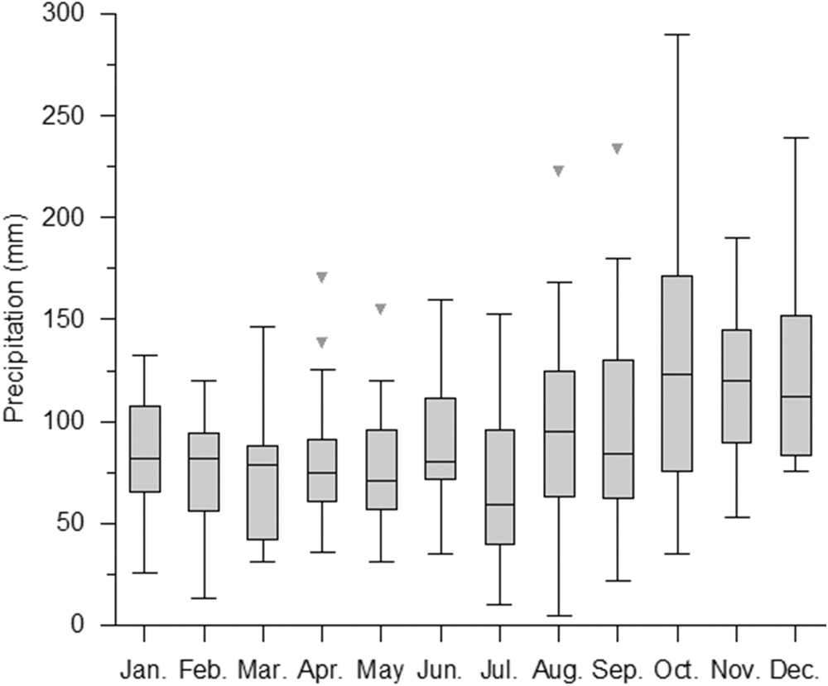

**Fig. 1.** Boxplot of monthly precipitation at Harrington (inverted triangles represent outliers; lines extending from the boxes indicate variability outside the upper and lower quartiles of monthly precipitation) (2001–2018).

exceeded precipitation and recharge was limited in potato fields be- tween June and October; evapotranspiration subsequently diminished and snowmelt and/or rainfall created significant recharge during October and May (Fig. 3). These results are consistent with the responses of groundwater level and stream flow to seasonal recharge as reported by Jiang et al. (2012) and Liang et al. (2020). GS ETc averaged 421 mm with a standard deviation of 18 mm (Table 1). The small standard de- viation indicates that annual variation of GS ETc was relatively small. While the precipitation averages in May and June were higher than the ETc values, the respective precipitation averages in July and August were 70 and 37 mm lower than the ETc values of the potato plant, indicating water deficiency in the critical growing period under rain-fed conditions (Fig. 4). The water deficiency was much more severe in the extremely dry season of 2001 (Fig. 4).

* 1. *Potato yield responses to precipitation and water deficiency/excess*

Variety-aggregated potato yields varied from 19.2 to 35 Mg/ha, with an average of 31.2 and standard deviation of 3.3 Mg/ha, and the RB yields varied from 16.3 to 33.2 Mg/ha, with an average of 29.5 and standard deviation of 3.8 Mg/ha (Table 1). The RB yields were slightly lower than the variety-aggregated yields partly because the RB yields represent marketable yields, which should be lower than the total yields. These yields were compatible with the data from a neighboring region (i. e. Maine, US) (Silver et al., 2011). In 2001, the GS precipitation was only 45% of averages of 2001–2018 (Table 1). The extreme dry conditions resulted in extremely low yields (variety-aggregated 19.2 Mg/ha vs. RB 16.3 Mg/ha). The regression between variety-aggregated yields and GS

precipitation produced a second-order polynomial curve with a perfect correlation (R2 = 0.88; P < 0.001) (Table 2). This regression indicates that GS precipitation accounted for 88% of the year-to-year variation in

potato yield. Potato yield increased with the initial increments of water supply from 150 to 360 mm, became relatively insensitive (i.e. pla- teauing) to water supplied from 360 to 460 mm, then decreased with very high water supplies (Fig. 5). Note that the yield-determining equation in Fig. 5 only characterizes how variety-aggregated yields respond to GS precipitation under average soil, weather and manage- ment conditions in PEI. As such, the yield of a specific variety from a specific field/year may deviate from this regression equation, depending on how the field’s soil and management practices differ from average conditions.

A perfect second-order polynomial correlation (R2 = 0.88;

P < 0.001) also exists between the variety-aggregated yields and GS

water deficiency/excess (Fig. 6; Table 2). The fact that GS water defi- ciency/excess was linearly correlated with GS precipitation (R2 = 0.98; P < 0.001) as a result of GS ETc being close to a constant (Table 1) can well explain why the two correlations are so similar. Maximizing potato

yield requires balancing the water supply and demand of potato plants in time and space. Applying this principle and the yield-determining equations in Figs. 5 and 6, supplementing water supply with irrigation

at 34–175 mm would be required in the majority (13/18 = 72.2%) of

the GSs, supplementing at 295 mm would be required in the 2001 sea-

son (5.5%) and dewatering at rates of 18–34 mm would be required for four (22.2%) GSs (i.e. 2002, 2008, 2009 and 2010), as the excessive water supply led to the yield going from plateauing to decreasing (Figs. 5 and 6).

The responses of RB yield to GS precipitation and water deficiency/

excess were also characterized by polynomial regression curves (Figs. 7 and 8). The correlations were significant (R2 = 0.77 and P < 0.001 for precipitation and R2 = 0.79 and P < 0.001 for water deficiency/excess)

(Table 1). These RB yield data indicate that GS precipitation and water deficiency/excess explained 77% and 79% of the yield variability, respectively. Although the variety-aggregated and RB data sets were from two different sources, they produced highly consistent statistical results. This consistency increases confidence in the yield-determining equations. Solving the derivatives of the yield-determining equations

**Table 1**

Historical potato yields and weather data in PEI.

|  |  |  |  |  |  |  |
| --- | --- | --- | --- | --- | --- | --- |
| Year | Variety-aggregated yield (Mg/ | RB yield (Mg/ | Jun.–Sep. precipitation | ETc | Jun.–Sep. water deficiency/ excess | Annual precipitation |
|  | ha) | ha) | (mm) | (mm) | (mm) | (mm) |
| 2000 |  | 29.8 | 296 | 413 | -117 | 1038 |
| 2001 | 19.2 | 16.3 | 155 | 450 | -295 | 787 |
| 2002 | 31.3 | 32.7 | 426 | 408 | 18 | 1297 |
| 2003 | 29.7 | 30.5 | 257 | 432 | -175 | 1024 |
| 2004 | 30.8 | 33.1 | 310 | 410 | -100 | 987 |
| 2005 | 30.8 | 31.8 | 302 | 431 | -129 | 1115 |
| 2006 | 33.6 | 33.2 | 326 | 424 | -98 | 1092 |
| 2007 | 33.6 | 29.9 | 358 | 392 | -34 | 946 |
| 2008 | 31.3 | 26.8 | 479 | 382 | 97 | 1198 |
| 2009 | 33.4 | 27.1 | 470 | 409 | 61 | 1253 |
| 2010 | 33.4 | 29.8 | 458 | 428 | 30 | 1212 |
| 2011 | 31.9 | 28.9 | 355 | 406 | -51 | 1319 |
| 2012 | 31.1 | 28.2 | 333 | 450 | -117 | 954 |
| 2013 | 31.5 | 28.4 | 326 | 428 | -102 | 1032 |
| 2014 | 31.4 | 31.1 | 329 | 422 | -93 | 1377 |
| 2015 | 31.3 | 31.0 | 316 | 415 | -99 | 1350 |
| 2016 | 32.5 | 32.0 | 328 | 427 | -99 | 1056 |
| 2017 | 30.5 | 30.1 | 300 | 436 | -136 | 925 |
| 2018 | 35.0 |  | 331 | 436 | -105 | 1135 |
| Ave. | 31.2 | 29.5 | 340 | 421 | -81 | 1110 |
| Stdev. | 3.3 | 3.8 | 77 | 18 | 89 | 162 |

Notes: weather data were from Harrington (Environment and Climate Change Canada Harrington weather station ECCC Harrington, 2020); missing weather data were filled using data from Charlottetown Airport weather station (Environment and Climate Change Canada Charlottetown Airport weather station ECCC Charlottetown Airport, 2020).

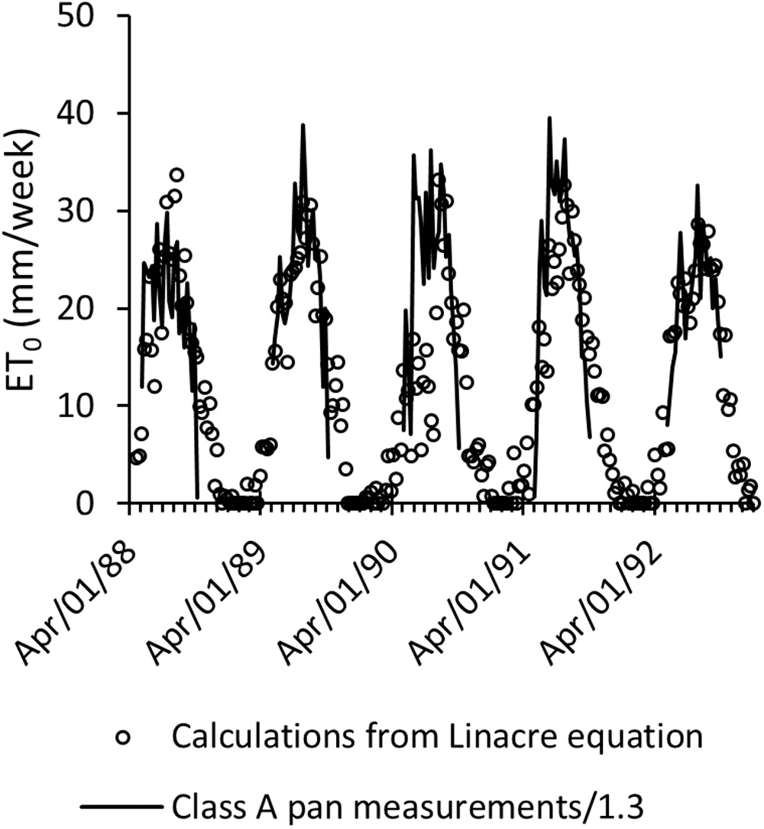

**Fig. 2.** Calculated and measured evapotranspiration at Harring- ton (1988–1992).

(Figs. 5 and 6) by setting the yields to zero produced the optimum water supply for the potato plant as 460 and 399 mm for the variety- aggregated and RB cases, respectively. This optimum water supply is

highly consistent with the optimum water demand of the potato plant as indicated by the GS average ETc = 421 mm. This consistency suggests that the estimations of the optimum water demand as indicated by ETc

are reliable. The optimum water demand rates calculated from the ETc data in Fig. 4 were 1.4, 2.6, 4.3, 4.3 and 2.4 mm per day in May, June, July, August and September, respectively.

Potato yield responded relatively insensitively as GS rainfall fell

within 360 and 460 mm (Fig. 5) or water deficiency/excess varied within about —100 and 100 mm (Fig. 6); for RB, the insensitive pre- cipitation fell within 300–400 mm (Fig. 7) or water deficiency/excess between about —70 and 0 mm (Fig. 8). Interestingly, similar insensitive yield responses and water supply ranges were also observed by Shay-

kewich et al. (2002) from supplemental irrigation experiments in Manitoba, Canada. This consistency implies that potato yield intrinsi- cally responds insensitively to a fairly large range of water supply as water supply approaches the optimum point. This is very similar to the insensitive yield response to a fairly large range of fertilizer N input before reaching the optimum N input point (e.g. Zebarth et al., 2012).

The insensitive water supply range provides an opportunity for growers to consider the lower (i.e. 360 mm as water supply or —100 mm as water deficiency/excess) instead of the upper bound (i.e. 460 mm as water

supply or 100 mm as water deficiency/excess) as a quasi-optimum SI water supply target. Adopting this quasi-optimum target can potentially not only produce a yield almost identical to the maximum yield as determined by the yield determining equation, but also reduce the cost of SI pumping and conserve water, which is important where water sources are limited in availability. It is worth noting that the insensitive water supply range likely varies with potato variety.

The timing of monthly precipitation in the GS influenced potato yields differently (Table 2). Precipitation in May was negatively corre-

lated with RB yields (R2 = 0.28; P < 0.1) because excessive soil moisture

in May can delay planting, which can in turn reduce RB yield as a result

of a shortened growing period for this long-season variety. In June, the potato plants initiated and established (esp. for the commonly-grown RB variety) when leaf area was small and temperatures were usually cool, water use (ETc) was relatively low (Fig. 4), while precipitation was relatively high (Fig. 1). As such, water deficiency likely did not occur and thus precipitation or water deficiency/excess in June did not affect potato yields significantly. In July, when tubers initiated, the plants were relatively sensitive to water stress. However, precipitation or water deficiency/excess in July did not impose a significant effect on yield (Table 2). Note that precipitation usually exceeded ETc in May and June (Fig. 4) in this humid region, which allowed the excessive precipitation to be stored in soil and carried over into July. This carried-over soil moisture may have mitigated some of the impacts of rainfall deficiency in July, resulting in the lack of significant yield response to July pre- cipitation. Precipitation in August significantly (positively) influenced

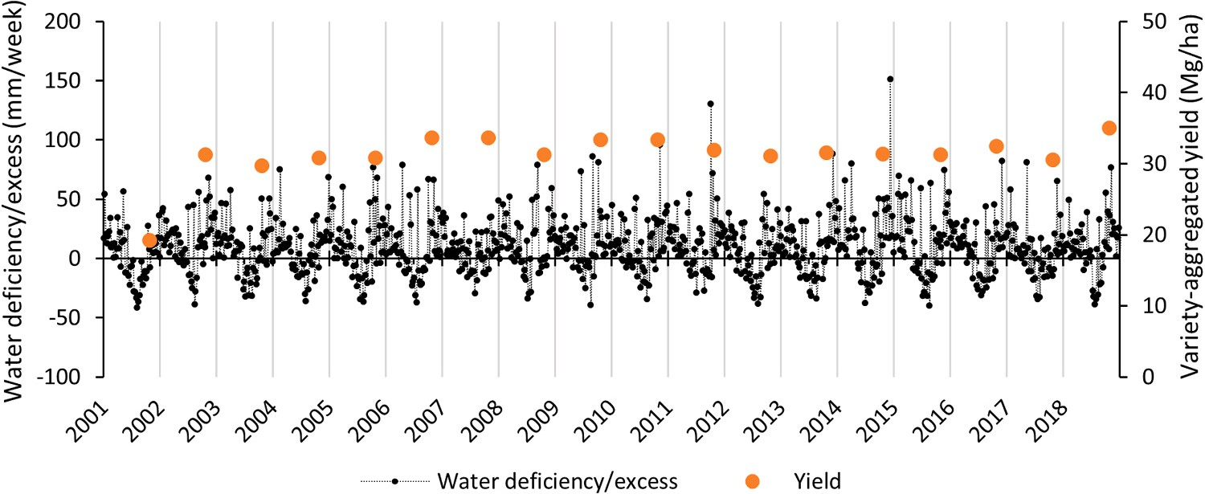

**Fig. 3.** Weekly water deficiency/excess of potato plant and variety-aggregated yield (2001–2018).

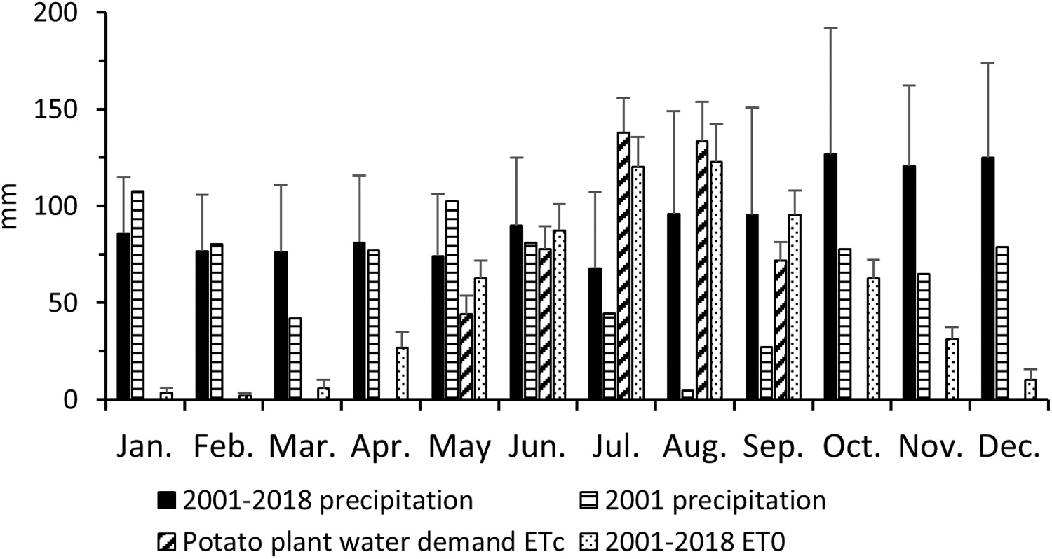

**Fig. 4.** Means and standard deviations of monthly precipitation, potential evapotranspiration (ET0) and potato plant water demand (ETc) (2001–2018).

**Table 2**

Results of polynomial regression analysis.

Source of variability (mm) Variety-aggregated yield (Mg/ha) RB yield (Mg/ha)

|  |  |  |  |  |  |  |  |  |
| --- | --- | --- | --- | --- | --- | --- | --- | --- |
|  | R2 Standard error | | P (ANOVA) |  | R2 Standard error P (ANOVA) | | |  |
| Jun.–Sep. precipitation | 0.88 | 1.2 | < 0.001 | 0.77 | | 1.9 | < 0.001 | |
| Jun.–Sep. water deficiency/excess | 0.88 | 1.2 | < 0.001 | 0.79 | | 1.8 | < 0.001 | |
| May precipitation | 0.08 | 3.4 | 0.5 | 0.28 | | 3.4 | 0.08 | |
| May water deficiency/excess | 0.08 | 3.4 | 0.5 | 0.26 | | 3.6 | 0.1 | |
| Jun. precipitation | 0.19 | 3.2 | 0.2 | 0.008 | | 4 | 0.9 | |
| Jun. water deficiency/excess | 0.17 | 3.2 | 0.2 | 0.14 | | 3.9 | 0.3 | |
| Jul. precipitation | 0.07 | 3.4 | 0.6 | 0.06 | | 3.9 | 0.6 | |
| Jul. water deficiency/excess | 0.02 | 3.5 | 0.8 | 0.14 | | 3.9 | 0.3 | |
| Aug. precipitation | 0.4 | 2.7 | 0.02 | 0.3 | | 3.4 | 0.06 | |
| Aug. water deficiency/excess | 0.65 | 2.1 | < 0.001 | 0.56 | | 2.8 | 0.03 | |
| Sep. precipitation | 0.21 | 3.1 | 0.2 | 0.18 | | 3.6 | 0.2 | |
| Sep. water deficiency/excess | 0.35 | 2.8 | 0.04 | 0.34 | | 3.4 | 0.05 | |

variety-aggregated (R2 = 0.4; P < 0.05) and RB (R2 = 0.3; P < 0.1) yields (Table 2). Water deficiency/excess in August also significantly influenced variety-aggregated (R2 = 0.65; P < 0.001) and RB (R2

= 0.56; P < 0.05) yields. This is probably because potato tubers were

bulking in August, when the potato plants were most sensitive to water

stress (Sexton et al., 2008). Water deficiency/excess in September was positively correlated with variety-aggregated (R2 = 0.35; P < 0.1) and RB yields (R2 = 0.34; P < 0.1). Having sufficient soil moisture in

September likely helped increase the yields by providing more time for the long-season variety to grow.

The optimum water demand rates of the potato plant and yield responding patterns as discussed above have important implications for SI management. As potato yields were less sensitive to water supply and water deficiency usually did not occur in June, implementing SI in this month to match the GS optimum water demand should be a lower pri- ority. Supplying water at 4.3 mm per day (i.e. 1.2 in. per week) in July

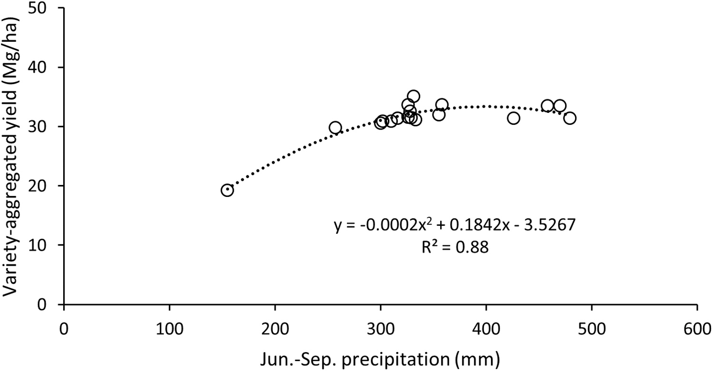

**Fig. 5.** Variety-aggregated potato yield responses to growing season precipitation (2001–2018).

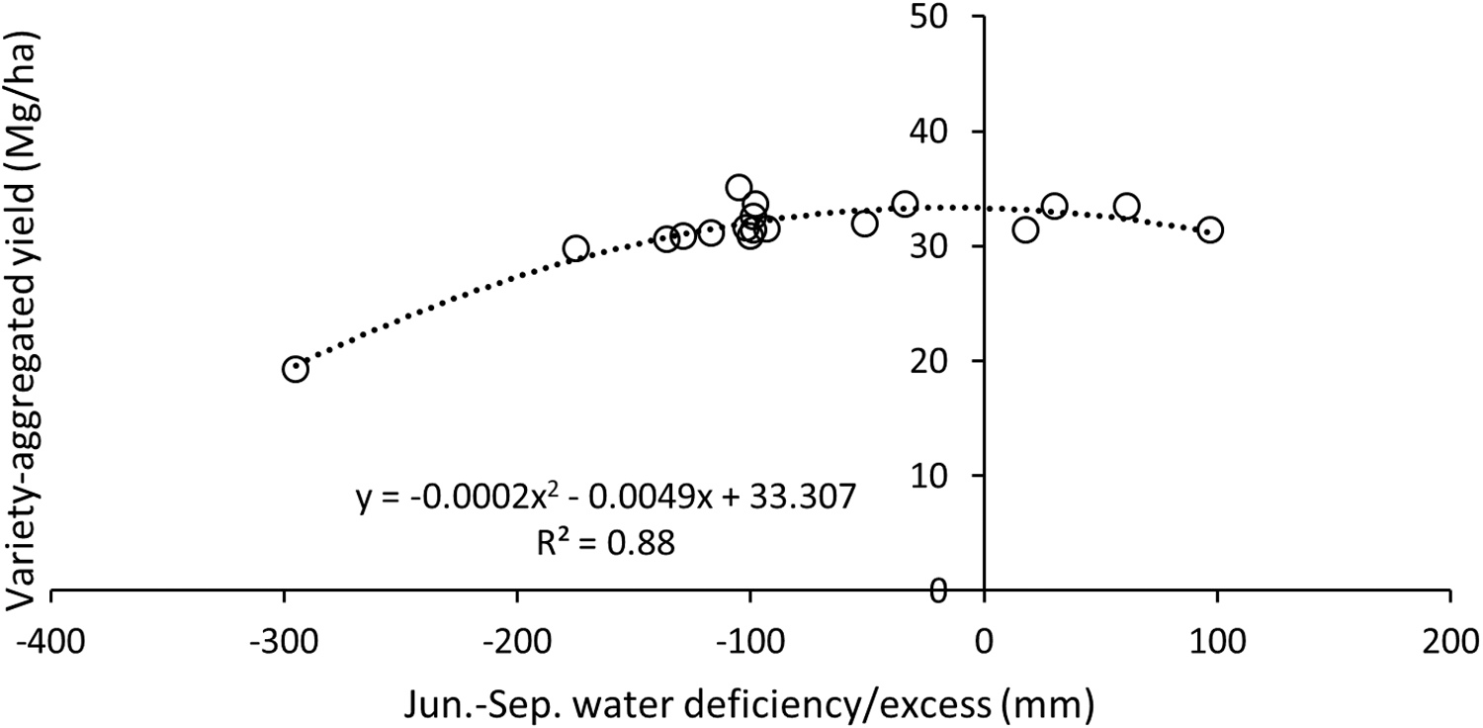

**Fig. 6.** Variety-aggregated potato yield responses to growing season water deficiency/excess (2001–2018).

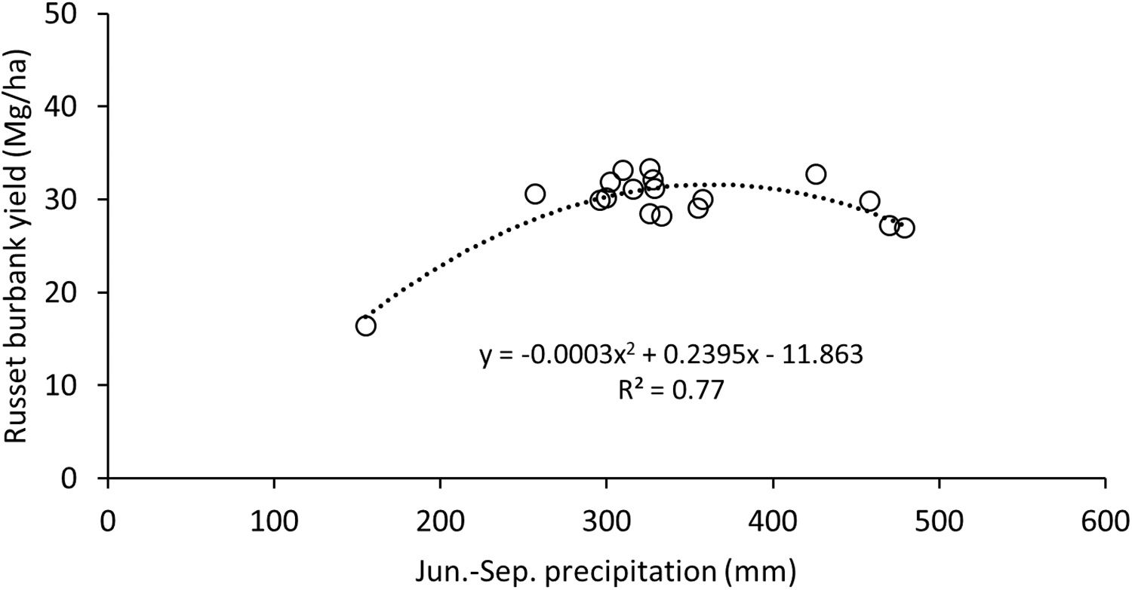

**Fig. 7.** Russet Burbank potato yield responses to growing season precipitation (2000–2017).

and August is important to achieve the optimum yield goal. For long- season varieties, applying 2.3 mm per day in September can help to achieve the optimum yield target. While adopting the GS quasi-optimum water demand targets for water conservation, reducing water input

should be done outside of August. Since irrigation is meant to supple- ment the water deficiency created by insufficient rainfall in this humid area, the recommended water supply rates must be deducted by local short-term forecasted rainfall in all cases. However, controlling water

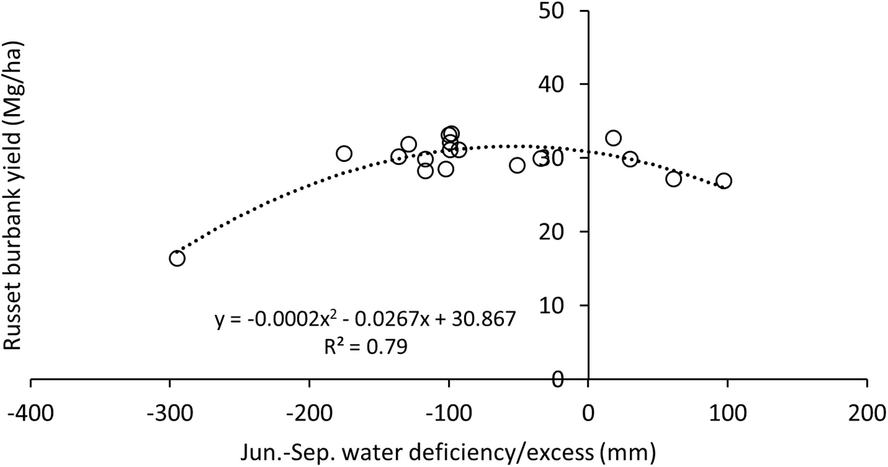

**Fig. 8.** Russet Burbank potato yield responses to growing season water deficiency/excess (2000–2017).

supply by matching SI plus GS rainfall with the optimum water demand targets is challenging as GS rainfall can vary substantially and is un- predictable in this humid area. As a result, applying a similar irrigation

rate (SI) in two growing seasons with two different rainfall rates (R1 and R2) can end up with two largely different GS water supply rates (SI + R1 vs. SI + R2) and yield responses. For example, if R1+ SI is in the sensitive range and R2+ SI is in the insensitive range as indicated in Fig. 5, SI + R1 can create a yield response but R2 + SI cannot. This may explain why

some growers who applied a similar irrigation rate observed a yield benefit in some seasons but not in other seasons in PEI (personal com- munications). Likewise, short-term irrigation experiments may also produce inconsistent yield responses to a similar irrigation rate in a humid area but the inconsistency as driven by two different GS water supply rates may be attributed to other factors by mistake because the experiments may not map out the responding patterns including both sensitive and insensitive ranges as shown in Fig. 5.

On an annual basis, both variety-aggregated (R2 = 0.73; P < 0.001) and RB (R2 = 0.53; P < 0.005) yields were significantly correlated with

annual precipitation using a second-order polynomial regression. However, the physics basis of these correlations is questionable, although annual precipitation was used to correlate with potato yield in Maine, US, by Benoit and Grant (1985). The fall–winter–early spring (off season) precipitation was normally higher than the GS precipitation (Fig. 3), but the majority of the off season precipitation became groundwater recharge, runoff and evapotranspiration, with the remaining water stored in the soil, which can create a saturated soil condition before planting potato crops (Jiang et al., 2011). However, growers are not able to plant potatoes under saturated or quasi-saturated soil conditions, as the agricultural equipment can get stuck in the wet fields. The machines cannot work in fields until the soil moisture de- creases below about 65% water holding capacity for the typical soils (loam or sandy loam) in PEI. This level of moisture, which was estimated to correspond to about 25 mm of available water in the top 30 cm of soil (where the majority of potato roots are present) by using relevant soil retention parameters, could diminish to the wilting point level through evapotranspiration within about 10 days without new precipitation and/or irrigation, given the typical crop ETc of 1.4–2.6 mm/d as shown before. In addition, this level of moisture only corresponds to a small fraction (7–8%) of GS precipitation averages (Table 1). Annual precip- itation was correlated with potato yield simply because annual precip-

itation was linearly correlated with GS precipitation (R2 = 0.46;

P < 0.01). As a consequence, annual precipitation is mathematically

correlated with potato yield but the yield responses were primarily

driven by GS precipitation. In other words, only the upcoming GS pre- cipitation, rather than the previous off season precipitation, had a sig- nificant impact on potato plant growth.

As identified above, GS precipitation as water supply was the dominant variable responsible for year-to-year variation of potato yield, which constitutes the key rationale for improving water management. The 18 years of yield and weather data also demonstrated a wide range of water supply scenarios (dry, quasi-optimum and wet) and are important for potato water management decision making in this region, particularly in the absence of long-term irrigation experiment data. However, the data were derived from random precipitation as water supply and may not fully reflect real-world SI conditions. Recommended optimum soil moisture thresholds for potato plant growth range from 65% to 85% water-holding capacity for vegetative growth, tuber initiative, and tuber bulking stages and from 50% to 65% water-holding capacity for maturation stages (e.g. Allen et al., 1998; Sexton et al., 2008). Although the precipitation in four (2002, 2007, 2010, 2011) of the 18 seasons was very close to the optimum water demand of the potato plant, whether the random precipitation rates (Table 1) could have consistently maintained soil moisture within the optimum thresholds for irrigation is unknown. It also remains to be verified whether strictly respecting the optimum moisture thresholds via SI could have greatly changed the yield response patterns as shown in Figs. 5–8. Irrigation studies conducted by Shock et al. (1998) in Oregon, US, and Lynch et al. (1995) in Alberta, Canada, suggested that a short duration of water stress can result in an appreciable reduction in tuber yield and quality. It should be noted that irrigation can meet the opti- mum moisture thresholds provided that precipitation does not exceed the water supply required for respecting the thresholds but cannot do so if the precipitation oversupplies water, unless soil dewatering is carried out in this humid region. In other words, consistently meeting the op- timum moisture thresholds would require a soil dewatering system such as tile drainage in addition to SI, as excessive water supply in the form of precipitation occurred in four out of the 18 years.

Since the RB yield case had similarities with the variety-aggregated

yield case in terms of yield responses to precipitation and water defi- ciency/excess, it was considered as a validation of the latter, and here- after discussions will only focus on the variety-aggregated yield case unless otherwise noted.

* 1. *Economic implications of supplemental irrigation*

As predicted by the yield-determining equation in Fig. 6, in an

**Table 3**

Summary of SI cost-benefit analysis (2018 prices).

Gross benefit created by yield gain due

Gross benefit created by yield

SI Costs for a 20-ha field ($/ha) SI Costs for a 40-ha field ($/ha)

to SI in an extremely dry year ($/ha)

|  |  |  |  |  |  |
| --- | --- | --- | --- | --- | --- |
|  | ($/ha) | development | development | development | development |
| 3040 | 754 | 2684 | 1505 | 1335 | 832 |

gain due to SI in most years

With water source

Without water source

With water source

Without water source

Notes: Potato yield responses to water supply (regardless of precipitation or irrigation or the combination of precipitation and irrigation) were assumed to follow the yield-determining equation in Fig. 5. An extremely dry year refers to 5.5% rainfall depth duration frequency and was represented by 2001; most years refer to 72.2% rainfall depth duration frequency and were represented by the years with GS precipitation ranging from 257 to 360 mm.

extremely dry year, such as 2001 (a rainfall depth duration frequency of 5.5%), applying irrigation at 295 mm would be required to increase the yield from the rain-fed level of 19.7 Mg/ha to the optimum SI level of 33

Mg/ha (i.e. 13.3 Mg/ha gain), although reaching a yield gain of 35–19.7 = 15.3 Mg/ha is also possible; in most years (a rainfall depth duration frequency of 72.2%), applying irrigation from 34 mm to

175 mm would be required to increase the yield from the rain-fed level of 29.7 Mg/ha to the optimum SI level of 33 Mg/ha (i.e. 3.3 Mg/ha gain). Assuming 90% of total yield being marketable yield (Jiang et al., 2019), multiplying the potato sale price (e.g. $254/Mg) with the yield gains produced the SI gross profits (Table 3). The gross profits represent increased gross profit from SI alone, as the growers would have to spend money on all other production costs regardless of SI.

Silver et al. (2011) categorized the 2010 SI costs in Maine, US, into three classes: capital costs (equipment, interest), water development (pond construction, permitting, engineering) and operating and main- tenance costs (labor, power, repair). They estimated the costs for hose reel traveler systems and center-pivot systems with or without water development costs at 20-, 40- or 80-ha field size categories, respectively as all these parameters influenced the overall costs. They also noted that their cost estimates had a variable component reflecting the demand for irrigation water as the demand for irrigation water was dependent upon rainfall. While operating costs increased with increasing amounts of irrigation applied, average cost declined. The respective average annual costs at 2010 prices associated with a center-pivot system with and without water source development at 20- and 40-ha field sizes reported by Silver et al. (2011) were used as reference costs. These reference costs were adjusted for inflation using an annual inflation average of 1.78% ([https://www.usinflationcalculator.com/inflation/historical-inflation](https://www.usinflationcalculator.com/inflation/historical-inflation-rates/)

[-rates/](https://www.usinflationcalculator.com/inflation/historical-inflation-rates/), accessed 28 July 2020) and converted into Canadian currency by using the 2018 conversion rate (1.3). Deducting the gross benefits of SI with the SI costs produces the net financial benefit of SI (Table 3).

Based on the cost and benefit data in Table 3, SI has to increase total potato yield by over 10.6 and 5.9 Mg/ha for a 20-ha field size scenario and 5.2 and 3.3 Mg/T for a 40-ha field size scenario with and without water source development, respectively, in order to generate net profile. As expected, in an extremely dry year such as 2001, SI could have substantially increased financial benefits as a result of potential total yield increase from 19.2 to 33 Mg/ha regardless of 20- and 40-ha field sizes with and without water source development, compared to rain-fed production (Table 3). However, this only occurred in 5.5% of the 18 years. In most of the 18 years, SI would have induced negative financial benefits in both 20-ha and 40-ha field sizes with and without water source development (Table 3). If SI could have boosted the yield from

29.7 to 35 as shown in Fig. 5 in some seasons, the gross profit ($1146/ ha) from SI would only offset the SI costs ($832/ha) in a 40-ha field size scenario, without water source development costs incurred. These re- sults demonstrate a great financial challenge of implementing SI in this traditionally rain-fed production area. How the costs in Maine, US, compare with the costs in PEI is yet to be fully assessed, particularly given PEI’s smaller fields and undulating, often challenging terrain for center-pivot systems. In addition, SI can influence potato quality pa- rameters (Lynch et al., 1995; Porter et al., 1999), such as scab and specific gravity, which can greatly influence potato sale price and

associated profitability as well. This is beyond the scope of this work. However, the potential yield gains observed here in response to rainfall suggest more work needs to be done to assess if strictly respecting soil moisture as required by optimum potato plant growth by SI coupled with optimizing other potato production management variables can enhance potato productivity and quality to make SI consistently profitable.

* 1. *Implications of supplemental irrigation for groundwater management*

Assuming equal water access for irrigating all potato lands (31% of land mass) in the Wilmot River watershed and annual recharge average being 400 mm as estimated by Jiang et al. (2004) and Liang et al. (2020), potential SI would utilize 2.6–13.5% of annual recharge average (i.e. 31% of 34 mm/400 mm to 175 mm/400 mm) in 72% of the 18 years, and 23% of annual recharge average (i.e. 31% of 295 mm/400 mm in the extremely dry 2001 season) in 5.5% of the 18 years based on water deficiency as shown in Fig. 6. Although the po- tential extractions were not high compared to the annual recharge average, except in the 2001 season, it is important to recognize that irrigation extraction would mainly utilize groundwater storage as irri- gation only occurs during the GS, when recharge is limited (Fig. 3). Groundwater used for irrigation in the GS is expected to be fully replenished in the aquifer by forthcoming recharge in this recharge-rich region. However, the concurrence of high extraction for irrigation with low recharge in the GS, especially in the extremely drought-prone sea- son of 2001(representing the worst-case scenario), could impose high seasonal stress on the groundwater discharge-dependent ecosystems by significantly reducing groundwater discharge into the receiving tribu- taries. Addressing the seasonal conflict of water uses between the environment and humans in an intensively-farmed watershed poses a great challenge for groundwater management in this humid region.

# Conclusions

The 2001–2018 variety-aggregated potato yield responses to GS precipitation were characterized by second-order polynomial equations with 88% of the variation of the yield being explained by GS precipi- tation. Variety-aggregated yield increased from 19.2 to 33 Mg/ha as GS precipitation increased from 155 to 360 mm, responded relatively insensitive (33–35 Mg/ha) as GS precipitation varied within 360–460 mm and then decreased to 31 Mg/ha as GS precipitation exceeded 460 mm. Similar correlation exists between the 2000–2017 Russet Burbank (RB) potato yields and GS precipitation. GS ETc of the potato plant was estimated to be 421 mm, which was consistent with the optimum water demands (399–460 mm) determined from the second- order polynomial regressions between potato yields and GS precipita- tion. To maximize potato yield, 16 out of the 18 GSs would require various levels (30–300 mm) of supplemental irrigation, while four out of the 18 seasons would require dewatering soil at 30–100 mm to mitigate excessive water supply. On a monthly basis, precipitation and water deficiency/excess in August significantly (positively) influenced variety- aggregated and RB yields; precipitation in May significantly (negatively) influenced RB yield while water deficiency/excess in September

significantly (positively) influenced both variety-aggregated and RB yields. Supplemental irrigation using a center-pivot system would generate net profit in an extremely dry year such as 2001 but would lead to a net loss of profit in most years under both a 20 ha and a 40 ha field size scenarios. Irrigation extractions could use at anywhere between 2.6% and 23% of annual average recharge in one of the most intensively potato-cropped watersheds, depending on the year. While the ground- water consumed by irrigation in the GS can be replenished by the forthcoming recharge, the concurrence of high extraction for irrigation with low recharge in the dry season, especially in an extremely drought- prone season such as 2001, could impose high seasonal stress on the groundwater discharge-dependent ecosystems in an intensively-farmed watershed in this humid region. This study demonstrates that long- term yield responses to precipitation in a temperate humid climate can provide important information for making decision about SI man- agement and water resources allocation where short-term control ex- periments cannot provided that the influences on yield from other management and soil factors do not outweigh water supply.

# Declaration of Competing Interest

The authors declare that they have no known competing financial interests or personal relationships that could have appeared to influence the work reported in this paper.

# Acknowledgments

This work was supported by the Agriculture and Agri-Food Canada’s Living Labs in Atlantic Canada with grant ID as J-002269 led by Dr. Yefang Jiang. We thank the PEI Agriculture Insurance Corporation for providing the RB yield data and Ana Kostic for proofreading the English.

# References

Afzaal, H., Farooque, A.A., Abbas, F., Acharya, B., Esau, T., 2020. Precision irrigation Strategies for Sustainable water budgeting of potato crop in Prince Edward Island. Sustainability 12 (12), 2419. <https://doi.org/10.3390/su12062419>.

Agriculture and Agri-Food Canada, 2019, Potato market Information review 2018–2019.

〈[https://www.agr.gc.ca/resources/prod/doc/pdf/potato_market_review_revue_](http://www.agr.gc.ca/resources/prod/doc/pdf/potato_market_review_revue_) marche_pomme_terre_2018-eng.pdf〉 (accessed 17 August 2020).

[Allen, R., Pereira, L., Raes, D., Smith, M., 1998. Crop Evapotranspiration-guidelines for](http://refhub.elsevier.com/S0378-3774(21)00312-7/sbref2) [Computing Crop Water Requirements. FAO Irrigation and Drainage Paper 56. FAO,](http://refhub.elsevier.com/S0378-3774(21)00312-7/sbref2) [Rome, pp. 1–300](http://refhub.elsevier.com/S0378-3774(21)00312-7/sbref2).

Alva, A.K., 2008. Water management and water uptake efficiency by potatoes: a review. Arch. Agron. Soil Sci. 54, 53–68. <https://doi.org/10.1080/03650340701615822>.

[Be´langer, G., Walsh, J.R., Richards, J.E., Milburn, P.H., Ziadi, N., 2000. Yield response of](http://refhub.elsevier.com/S0378-3774(21)00312-7/sbref4)

[two potato cultivars to supplemental irrigation and N fertilization in New Brunswick.](http://refhub.elsevier.com/S0378-3774(21)00312-7/sbref4) [Am. J. Potato Res. 77, 11–21](http://refhub.elsevier.com/S0378-3774(21)00312-7/sbref4).

[Benoit, G.R., Grant, W.J., 1985. Excess and deficient water stress effects on 30 years of](http://refhub.elsevier.com/S0378-3774(21)00312-7/sbref5) [Aroostook county potato yields. Am. Potato J. 62, 49–55](http://refhub.elsevier.com/S0378-3774(21)00312-7/sbref5).

[Bernard, G., Aseidu, S.K., Boswall, P. (Eds.), 1993. Atlantic Canada potato guide. Atlantic](http://refhub.elsevier.com/S0378-3774(21)00312-7/sbref6) [Provinces Agricultural Services Coordinating Committee, Publ. 1300/93. Agdex 257.](http://refhub.elsevier.com/S0378-3774(21)00312-7/sbref6) [APASCC, Fredericton, NB](http://refhub.elsevier.com/S0378-3774(21)00312-7/sbref6).

[Bethke, P.C., Nassar, A.M.K., Kubow, S., Leclerc, Y.N., Li, X., Haroon, M., Molen, T.,](http://refhub.elsevier.com/S0378-3774(21)00312-7/sbref7) [Bamberg, J., Martin, M., Donnelly, D.J., 2014. History and origin of Russet Burbank](http://refhub.elsevier.com/S0378-3774(21)00312-7/sbref7) [(Netted Gem) a sport of Burbank. Am. J. Potato Res. 91, 594–609](http://refhub.elsevier.com/S0378-3774(21)00312-7/sbref7).

Brouwer, C., Prins, K., Heibloem, M., 1989, Irrigation water management: irrigation scheduling, 〈<http://www.fao.org/3/T7202E/t7202e00.htm#Contents>〉 (accessed 28 July 2020).

[Cantore, V., Wassar, F., Yamaç, S.S., Sellami, M.H., Albrizio, R., Stellacci, A.M.,](http://refhub.elsevier.com/S0378-3774(21)00312-7/sbref8) [Todorovic, M., 2014. Yield and water use efficiency of early potato grown under](http://refhub.elsevier.com/S0378-3774(21)00312-7/sbref8) [different irrigation regimes. Int. J. Plant Prod. 8, 409–427](http://refhub.elsevier.com/S0378-3774(21)00312-7/sbref8).

[Cook, B.I., Smerdon, J.E., Seager, R., Coats, S., 2014. Global warming and 21st century](http://refhub.elsevier.com/S0378-3774(21)00312-7/sbref9) [drying. Clim. Dyn. 43, 2607–2627](http://refhub.elsevier.com/S0378-3774(21)00312-7/sbref9).

DeFauw, S.L., He, Z.Q., Larkin, R.P., Mansour, S.A., 2012. Sustainable potato production and global food security. In: He, Z., Larkin, R.P., Honeycutt, C.W. (Eds.), Sustainable Potato Production: Global Case Studies. Springer, New York, pp. 3–19. [https://doi.](https://doi.org/10.1007/978-94-007-4104-1_1) [org/10.1007/978-94-007-4104-1_1](https://doi.org/10.1007/978-94-007-4104-1_1).

Environment and Climate Change Canada Charlottetown Airport weather station (ECCC Charlottetown Airport) 〈[http://climate.weather.gc.ca/climate_data/daily_data_e.](http://climate.weather.gc.ca/climate_data/daily_data_e) html?StationID=50621〉 (46◦17’21"N, 63◦7′9"W, accessed 28 July 2020).

Environment and Climate Change Canada Harrington weather station (ECCC Harrington)

〈https://climate.weather.gc.ca/climate_data/daily_data_e.html? hlyRange=2004–03-25%7C2020–07-27&dlyRange=2000–07-01%7C2020–07-

27&mlyRange=2000–07-01%7C2007–07-01&StationID=30308&Prov=PE& urlExtension=_e.html&searchType=stnProv&optLimit=yearRange&StartYear= 1840&EndYear=2020&selRowPerPage=25&Line=23&lstProvince=PE& timeframe=2&Day=27&Year=2018&Month=7#〉 (46◦20’37"N, 63◦10’11"W,

accessed 28 July 2020).

[Epstein, E., Grant, W.J., 1973. Water stress relations of the potato plant under field](http://refhub.elsevier.com/S0378-3774(21)00312-7/sbref11) [conditions. Agron. J. 65, 400–404](http://refhub.elsevier.com/S0378-3774(21)00312-7/sbref11).

[Jiang, Y., Nishimura, P., van den Heuvel, M., MacQuarrie, K.T.B., Crane, C., Xing, Z.,](http://refhub.elsevier.com/S0378-3774(21)00312-7/sbref12) [Raymond, B., Thompson, B., 2015. Modeling land-based nitrogen loads from](http://refhub.elsevier.com/S0378-3774(21)00312-7/sbref12) [groundwater-dominated agricultural watersheds to estuaries to inform nutrient](http://refhub.elsevier.com/S0378-3774(21)00312-7/sbref12) [reduction planning. J. Hydrol. 529, 213–230](http://refhub.elsevier.com/S0378-3774(21)00312-7/sbref12).

Jiang, Y., Nyiraneza, J., Khakbazan, M., Geng, X., Murray, B., 2020. Carbon-silica mesoporous composite in situ prepared from coal gasification fine slag by acid leaching method and its application in nitrate removing. Sci. Total Environ. 707, 136102 <https://doi.org/10.2134/age2019.05.0032>.

Jiang, Y., Somers, G., and Mutch, J., 2004, Application of numerical modeling to groundwater assessment and management in Prince Edward Island. Paper in Proc. of the 57th Canadian Geotechnical Conference and the 5th Joint CGS/IAH-CNC Conference, Quebec City, QC, 24–27 October 2004.

[Jiang, Y., Somers, G., 2009. Modeling effects of nitrate from non-point sources to](http://refhub.elsevier.com/S0378-3774(21)00312-7/sbref14) [groundwater in an agricultural watershed in Prince Edward Island, Canada.](http://refhub.elsevier.com/S0378-3774(21)00312-7/sbref14) [Hydrogeol. J. 17, 707–724](http://refhub.elsevier.com/S0378-3774(21)00312-7/sbref14).

[Jiang, Y., Zebarth, B.J., Somers, G.H., MacLeod, J.A., Savard, M.M., 2012. Nitrate](http://refhub.elsevier.com/S0378-3774(21)00312-7/sbref15) [leaching from potato production in Eastern Canada. In: He, Z., Larkin, R.P.,](http://refhub.elsevier.com/S0378-3774(21)00312-7/sbref15) [Honeycutt, C.W. (Eds.), Sustainable Potato Production: Global Case Studies.](http://refhub.elsevier.com/S0378-3774(21)00312-7/sbref15) [Springer, New York, pp. 233–250](http://refhub.elsevier.com/S0378-3774(21)00312-7/sbref15).

Liang, K., Jiang, Y., Qi, J., Fuller, K., Nyiraneza, J., Meng, F., 2020. Characterizing the impacts of land use on nitrate load and water yield in an agricultural watershed in Atlantic Canada. Sci. Total Environ. 729, 138793 [https://doi.org/10.1016/j.](https://doi.org/10.1016/j.scitotenv.2020.138793) [scitotenv.2020.138793](https://doi.org/10.1016/j.scitotenv.2020.138793).

[Linacre, E.T., 1977. A simple formula for estimating evaporation rates in various](http://refhub.elsevier.com/S0378-3774(21)00312-7/sbref17) [climates, using temperature data alone. Agr. For. Meteorol. 18, 409–424](http://refhub.elsevier.com/S0378-3774(21)00312-7/sbref17).

[Linacre, E.T., 1993. Data-sparse estimation of lake evaporation using a simple Penman](http://refhub.elsevier.com/S0378-3774(21)00312-7/sbref18) [equation. Agr. For. Meteorol. 64, 237–256](http://refhub.elsevier.com/S0378-3774(21)00312-7/sbref18).

[van Loon, C.D., 1981. The effect of water stress on potato growth, development, and](http://refhub.elsevier.com/S0378-3774(21)00312-7/sbref19) [yield. American Potato. Am. J. Potato Res 58, 51–69](http://refhub.elsevier.com/S0378-3774(21)00312-7/sbref19).

[Lynch, D.R., Foroud, N., Kozub, G.C., Farries, B.C., 1995. The effect of moisture stress at](http://refhub.elsevier.com/S0378-3774(21)00312-7/sbref20) [three growth stages on the yield, components of yield and processing quality of eight](http://refhub.elsevier.com/S0378-3774(21)00312-7/sbref20) [potato varieties. Am. Potato J. 72, 375–386](http://refhub.elsevier.com/S0378-3774(21)00312-7/sbref20).

[MacDougall, J.I., Veer, C., Wilson, F., 1988. Soils of Prince Edward Island. Agriculture](http://refhub.elsevier.com/S0378-3774(21)00312-7/sbref21) [Canada, Supply and Services Canada, Ottawa, ON](http://refhub.elsevier.com/S0378-3774(21)00312-7/sbref21).

[Nyiraneza, J., Thompson, B., Stiles, K., Geng, X., Jiang, Y., Fillmore, S., 2017. Changes in](http://refhub.elsevier.com/S0378-3774(21)00312-7/sbref22) [soil organic matter over 18 years in Prince Edward Island, Canada. Can. J. Soil Sci.](http://refhub.elsevier.com/S0378-3774(21)00312-7/sbref22) [97, 745–756](http://refhub.elsevier.com/S0378-3774(21)00312-7/sbref22).

[Opena, G.B., Porter, G.A., 1999. Soil Management and supplemental irrigation effects on](http://refhub.elsevier.com/S0378-3774(21)00312-7/sbref23) [potato: II. Root growth. Agron. J. 91, 426–431](http://refhub.elsevier.com/S0378-3774(21)00312-7/sbref23).

[Penman, H.L., 1948. Natural evaporation from open water, bare soil and grass. Proc.](http://refhub.elsevier.com/S0378-3774(21)00312-7/sbref24)

[Roy. Soc., A 193, 120–145](http://refhub.elsevier.com/S0378-3774(21)00312-7/sbref24).

van de Poll, H.W., 1983, Geology of Prince Edward Island, Prince Edward Island Department of Tourism, Industry and Energy, Charlottetown, Prince Edward Island, Canada.

[Porter, G.A., Bradbury, W.B., Sisson, J.A., Opena, J.B., McBurnie, J.C., 1999. Soil](http://refhub.elsevier.com/S0378-3774(21)00312-7/sbref25) [management and supplemental irrigation effects on potato: I. Soil properties, tuber](http://refhub.elsevier.com/S0378-3774(21)00312-7/sbref25) [yield, and quality. Agron. J. 91, 416–425](http://refhub.elsevier.com/S0378-3774(21)00312-7/sbref25).

[Romero-Lankao, P., Smith, J.B., Davidson, D.J., Diffenbaugh, N.S., Kinney, P.L.,](http://refhub.elsevier.com/S0378-3774(21)00312-7/sbref26) [Kirshen, P., Kovacs, P., Villers Ruiz, L., 2014. North America. In: Barros, V.R.,](http://refhub.elsevier.com/S0378-3774(21)00312-7/sbref26) [Field, C.B., Dokken, D.J., Mastrandrea, M.D., Mach, K.J., Bilir, T.E., Chatterjee, M.,](http://refhub.elsevier.com/S0378-3774(21)00312-7/sbref26)

[Ebi, K.L., Estrada, Y.O., Genova, R.C., Girma, B., Kissel, E.S., Levy, A.N.,](http://refhub.elsevier.com/S0378-3774(21)00312-7/sbref26) [MacCracken, S., Mastrandrea, P.R., White, L.L. (Eds.), Climate Change 2014:](http://refhub.elsevier.com/S0378-3774(21)00312-7/sbref26) [Impacts, Adaptation, and Vulnerability. Part B: Regional Aspects. Contribution of](http://refhub.elsevier.com/S0378-3774(21)00312-7/sbref26) [Working Group II to the Fifth Assessment Report of the Intergovernmental Panel on](http://refhub.elsevier.com/S0378-3774(21)00312-7/sbref26) [Climate Change. Cambridge University Press, Cambridge, United Kingdom and New](http://refhub.elsevier.com/S0378-3774(21)00312-7/sbref26) [York, NY, USA, pp. 1439–1498](http://refhub.elsevier.com/S0378-3774(21)00312-7/sbref26).

[Sexton, P., Porter, G., Johnson, S.B., 2008. Irrigating potatoes in Maine, Bulletin #2439.](http://refhub.elsevier.com/S0378-3774(21)00312-7/sbref27)

[University of Maine Cooperative Extension](http://refhub.elsevier.com/S0378-3774(21)00312-7/sbref27).

Shaykewich, C., Raddatz, R., Ash, G., Renwick, R., Tomasiewicz, D., 2002, Water use and yield response of potatoes, Paper in Proc. of the 3rd Annual Manitoba Agronomists

Conference, 〈[https://www.umanitoba.ca/faculties/afs/MAC_proceedings/2002/](http://www.umanitoba.ca/faculties/afs/MAC_proceedings/2002/) pdf/shaykewich.pdf〉 (accessed 19 March 2021), 10–11 December 2002, Winnipeg,

MB, Canada. pp. 172–178.

[Shock, C., Feibert, E., Saunders, L., 1998. Potato yield and quality response to deficient](http://refhub.elsevier.com/S0378-3774(21)00312-7/sbref28) [irrigation. Hort. Sci. 33, 655–659](http://refhub.elsevier.com/S0378-3774(21)00312-7/sbref28).

Silver, D., Afeworki, E., Criner, G., 2011, Cost of supplemental irrigation for potato production in Maine. Maine Agricultural and Forest Experiment Station Technical Bulletin 205.

Statistics Canada, Canadian potato production at 〈https://www150.statcan.gc.ca/n1/en/ catalogue/22–008-X〉 (accessed 8 April 2020).

Steele, C., 2013, Irrigation and Water Use (Best Practice Guide for Potatoes) UK Potato Council, 〈https://potatoes.ahdb.org.uk/sites/default/files/publication_upload/ Irrigation%20for%20potatoes_0.pdf〉 (accessed 10 June 2020).

[Unlu, M., Kanber, R., Senyigit, U., Onaran, H., Diker, K., 2006. Trickle and sprinkler](http://refhub.elsevier.com/S0378-3774(21)00312-7/sbref29) [irrigation of potato (Solanum tuberosum L.) in the middle Anatolian region in](http://refhub.elsevier.com/S0378-3774(21)00312-7/sbref29) [Turkey. Agric. Water Manag. 79, 43–71](http://refhub.elsevier.com/S0378-3774(21)00312-7/sbref29).

[Xing, Z., Chow, L., Li, S., Meng, F., 2012. Effects of hay mulch on soil properties and](http://refhub.elsevier.com/S0378-3774(21)00312-7/sbref30) [potato tuber yield under irrigation and nonirrigation in New Brunswick, Canada.](http://refhub.elsevier.com/S0378-3774(21)00312-7/sbref30)

[J. Irrig. Drain. Eng. 138, 703–714](http://refhub.elsevier.com/S0378-3774(21)00312-7/sbref30).

[Xing, Z., Chow, L., Meng, F., Rees, H., Lionel, S., Monteith, J., 2008. Validating](http://refhub.elsevier.com/S0378-3774(21)00312-7/sbref31) [evapotranspiration equations using bowen ratio in New Brunswick, Maritime,](http://refhub.elsevier.com/S0378-3774(21)00312-7/sbref31) [Canada. Sensors 8, 412–428](http://refhub.elsevier.com/S0378-3774(21)00312-7/sbref31).

[Zebarth, B.J., Belanger, G., Cambouris, A.N., Ziadi, N., 2012. Nitrogen fertilization](http://refhub.elsevier.com/S0378-3774(21)00312-7/sbref32) [strategies in relation to potato tuber yield, quality and crop N recovery. In: He, Z.,](http://refhub.elsevier.com/S0378-3774(21)00312-7/sbref32) [Larkin, R.P., Honeycutt, C.W. (Eds.), Sustainable Potato Production: Global Case](http://refhub.elsevier.com/S0378-3774(21)00312-7/sbref32) [Studies. Springer, New York, pp. 165–186](http://refhub.elsevier.com/S0378-3774(21)00312-7/sbref32).